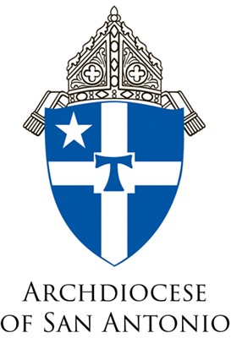

Suggested text to accompany all Parish Ministry Formation social media graphics for Called and Sent:

Attention all Catholic adults, ministry leaders, and volunteers: The course “Called and Sent” will be offered at [PARISH] on [Date]. This course is presented by the Archdiocesan Institute for Lay Ecclesial Ministry and Service in partnership with the Mexican American Catholic College. Contact [NAME] at [EMAIL] or [PHONE NUMBER] for more information or visit our website to register: https://maccsa.regfox.com/parish-ministry-formation. Come learn about your Catholic faith!

