Entrelazando Culturas en Vocaciones ~
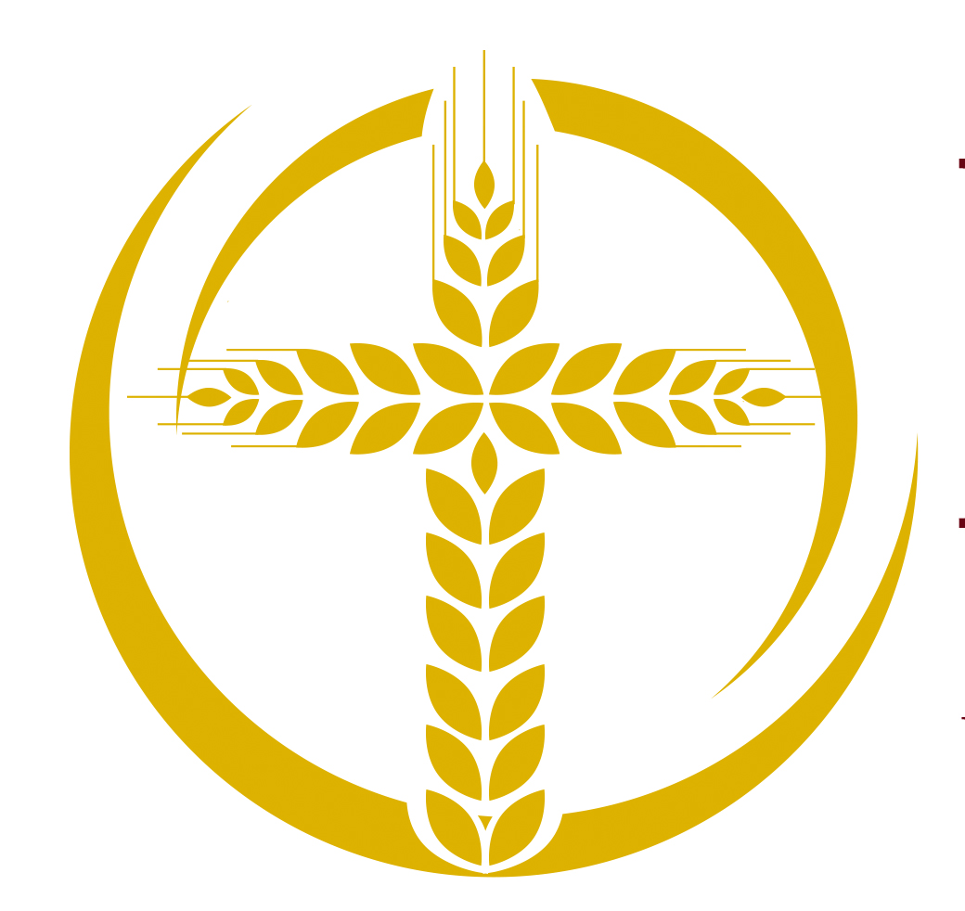
Weaving Cultures in Vocations

- Countries of Origin of Newer Entrants from 2003-2018

A quarter of new members (24 percent) were born in a country other than the United States. Respondents who were born outside the United State represent 68 countries.

The most common countries that were mentioned are Vietnam (4%), Mexico (3%), the Philippines (2%), and Canada (2%). Men are just slightly more likely than women to have been born outside the United States (26 percent compared to 22 percent).

- Geographic Regions in the United States of Perpetually Professed Women & Men

The regions described in this analysis conform to U.S. Census regions and include the following states: Northeast (CT, MA, ME, NH, NJ, NY, PA, RI, VT), South Atlantic (DE, DC, FL, GA, MD, NC, SC, VA, WV), South Central (AL, AR, KY, LA, MS, OK, TN, TX), Midwest (IA, IL, IN, KS, MI, MN, MO, ND, NE, OH, SD, WI), Mountain West (AZ, CO, ID, MT, NM, NV, UT, WY), Pacific West (AK, CA, HI, OR, WA), Outside the United States (Puerto Rico, Guam, and other U.S. territories included here).

- Ethnicities and Races

- Intergenerational Living

Age Distribution and Median Age: Final/Perpetual Vows
Percentage in each category

All Men Women
% % %
Under 40 3 6 2
40-49 4 7 2
50-59 6 12 4
60-69 11 19 9
70-79 31 27 32
80-89 32 22 36
90 and over 13 7 15

